**Cardboard Scrum - Game Specification**

**Game Objective:**

* The objective of the game is to collaboratively build a city using cardboard following the simplify Scrum process. This activity is to let you familiarized with the simplify Scrum process and able to apply the full Scrum process in software development in the following weeks.

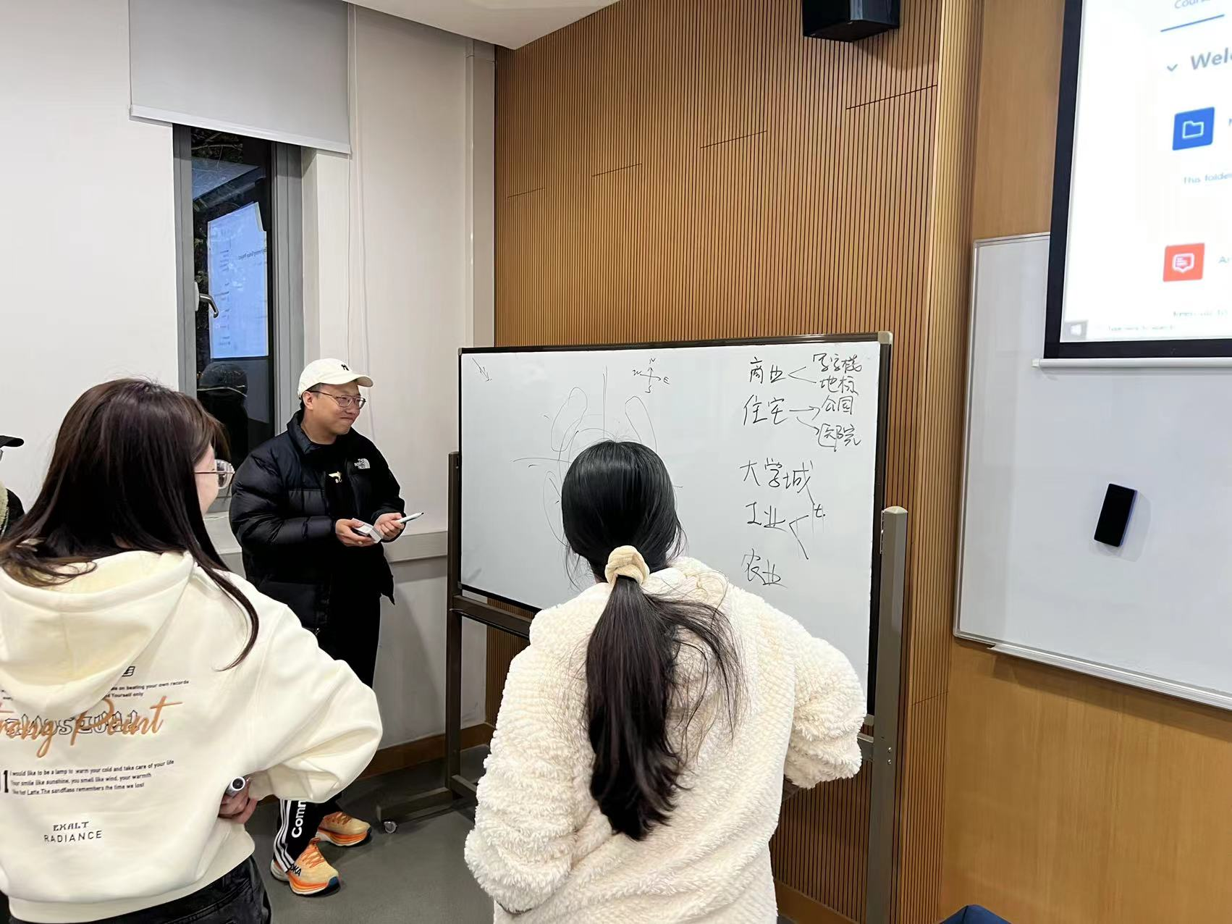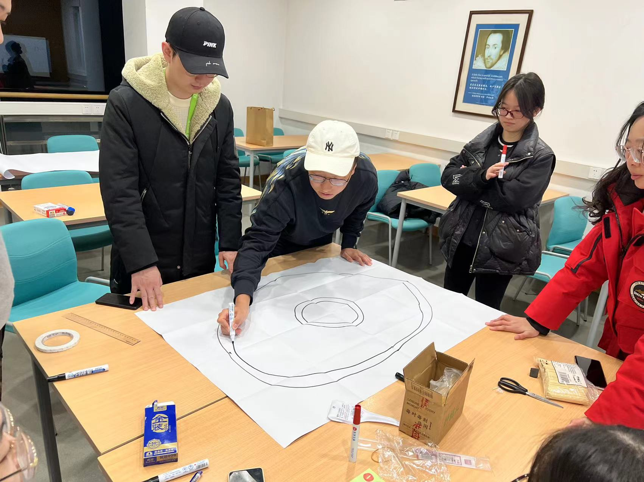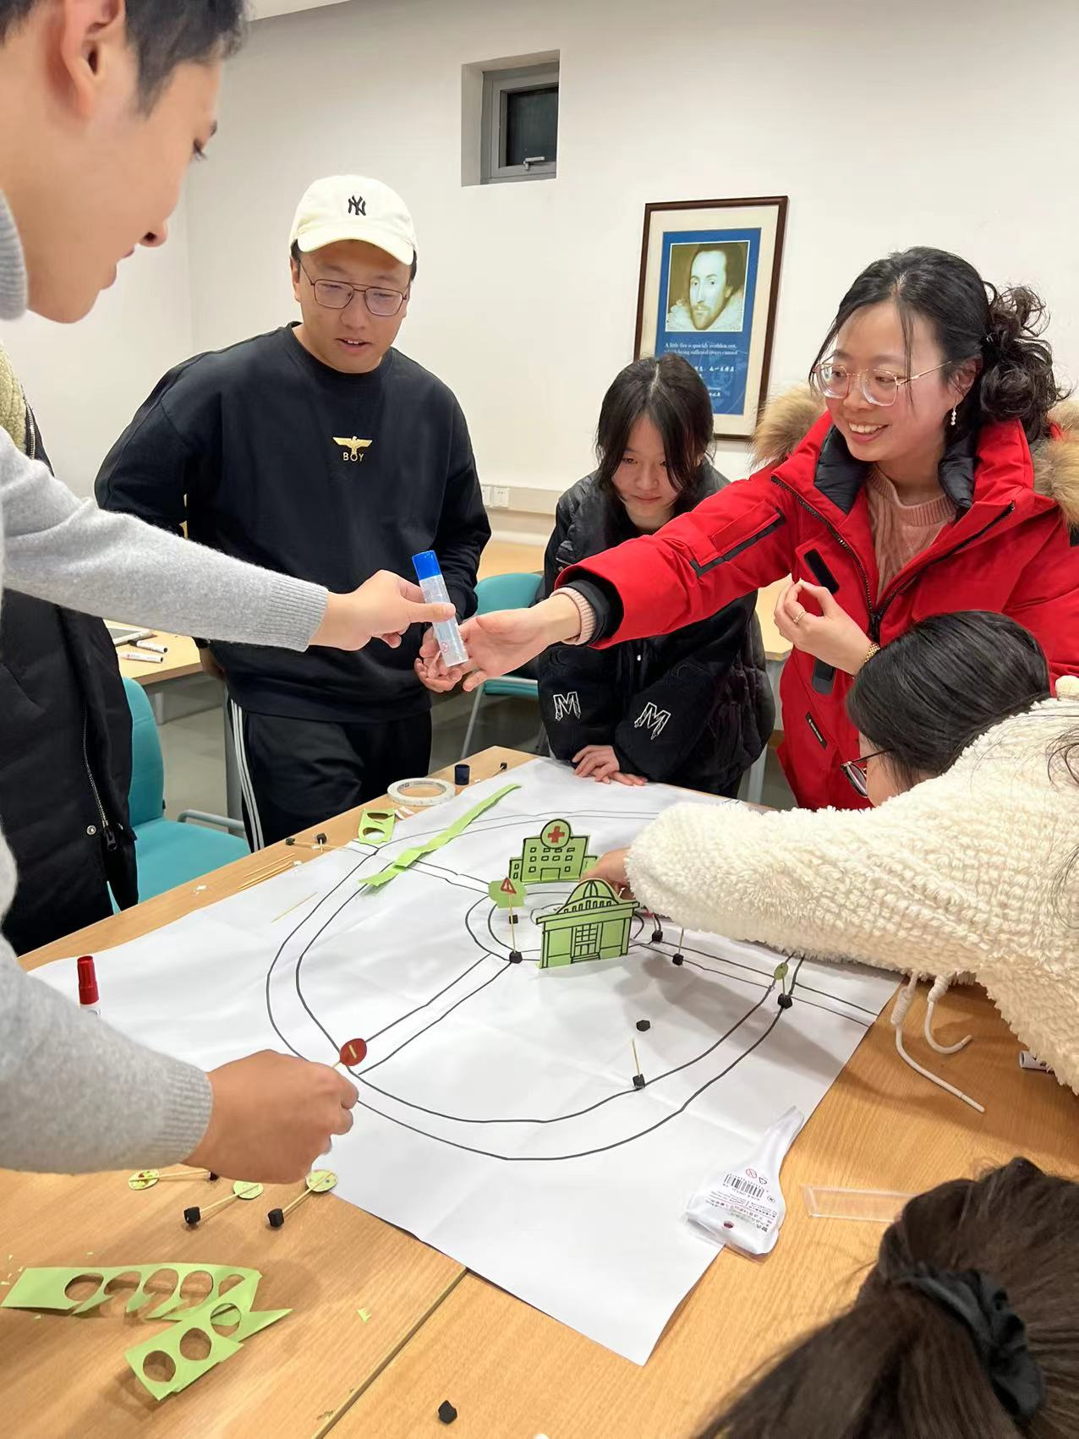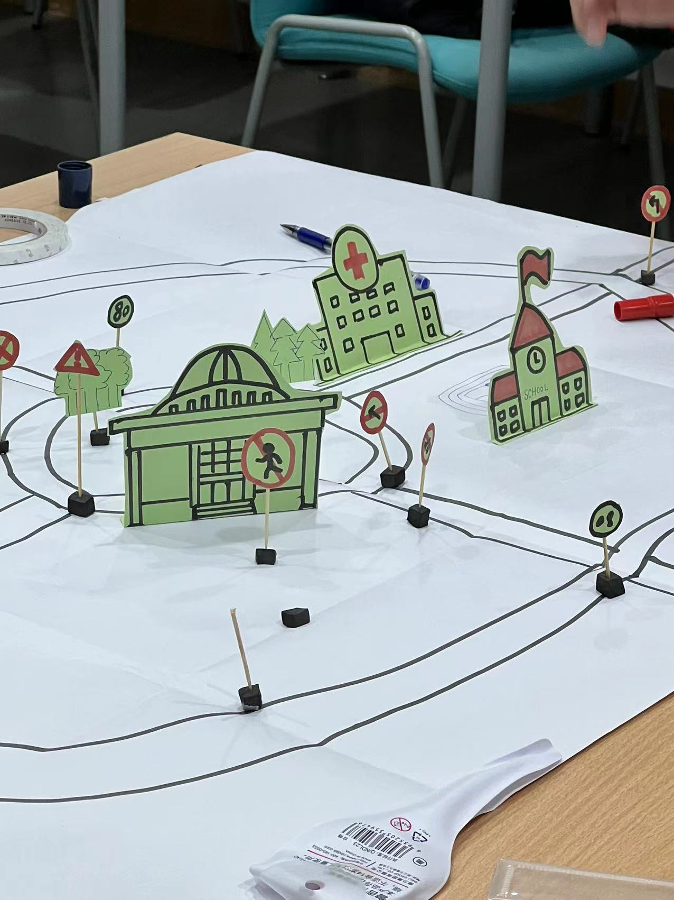

**Team Formation:**

* Students are divided into multiple Scrum teams, ideally 7 - 9 members per team.
* The members of the team should take full participation in building a city using cardboard.
* For this exercise, the all students must take a role. The role will remain unchanged for the entire exercise.
* Available roles: Architect (To draw the builder), Builder (To cut the drawing from the cardboard, to make the drawing stands, etc.), and Painter (To paint the drawing, to decorate the building, etc.).
* Multiple students can take a same role. For example, your team may have 2 architect, 3 builders, and 3 painters.

**Timing:**

* Timing is an important element;
* TA will announce the steps to be taken and the time allocation for each step.
* It is important to follow the time allocation strictly.

**Product Backlog:**

* Product backlog will be given to all teams.
* In the real practice while the Product Owner is responsible to set the PBI priority, in this exercise, the team will set the PBI priority collaboratively.
* During PBI grooming, all members must ensure that they understand the PBI.

**Sprint Planning:**

* Each team should conduct a sprint planning session before starting each sprint.
* Teams should select backlog items they can complete within the 30-minute sprint duration according to goals announce by the TA for each Sprint.
* Fill up the Sprint Backlog while doing the planning, you have to show your sprint backlog to TA later.

**Sprint Execution:**

* During the sprint execution, teams collaborate to build their portion of the city using cardboard.
* Each developer in the team must carry out the tasks according to their role.
* Teams should follow Scrum practices, including: -
  + Daily stand-ups to discuss progress, impediments, and plans for the day. Do it when the TA announce.
  + Participate in product backlog grooming upon TA’s calling. Perform grooming on the PBI to be build next.

**Sprint Review and Retrospective:**

* At the end of each sprint, teams spend 15 minutes to present their work to all participants and receive feedback on their city build. TA will check your sprint backlog against what you have completed.
* Conduct a 10 minutes retrospective to reflect on the sprint, identify improvements, and plan for the next sprint. The retrospective is an internal meeting within your team.

**Product Owner Role:**

* For the purpose of this exercise, this role is not included.

**Scrum Master Role:**

* For the purpose of this exercise, this role is not included.

**Developers Role:**

* Carry out the development according to your role to fulfill the requirements.

**IMPORTANT:**

* Perform activities according to TA announcement.
* Complete the activities according to the allocated time announced by the TA.
* Improve your work over each iteration.
* Students must discuss among team members and decide the role for each member.

**Timeline**

|  |  |  |
| --- | --- | --- |
| **Scrum Cardboard Game – Time Allocation** | | |
| **Time Allocation** | **Task** | **TA Action** |
| Upon entering | Distribute PBIs |  |
| 15 minutes | **Review goals and PBIs; Setting priority** |  |
| 10 minutes | Initial Product Backlog Grooming |  |
|  | Sprint Goal | Announce Sprint Goal |
| 8 minutes | Sprint 1 Planning | Review Sprint Backlog |
| 30 minutes | Sprint 1 Execution |  |
|  | Daily Scrum (3 minutes) |  |
|  | Grooming (6 minutes) |  |
| 15 minutes | Sprint 1 Review | Check against Sprint Backlog, provide feedback |
| 10 minutes | Sprint 1 Retrospective |  |
|  | Sprint Goal | Announce Sprint Goal |
| 8 minutes | Sprint 2 Planning | Review Sprint Backlog |
| 30 minutes | Sprint 2 Execution |  |
|  | Grooming (3 minutes) |  |
| 15 minutes | Sprint 2 Review | Check against Sprint Backlog, provide feedback |
| 10 minutes | Sprint 2 Retrospective |  |
|  |  |  |
|  | Conclusion | Invite team representation to conclude |
|  | Pack, clean up, and leave |  |
|  |  |  |

**Sprint Backlog**

* 1. You will get a printed copy of the below Sprint Backlog. Use it to record your Sprint Planning.
  2. Upon asking, you need to present it to the TA.

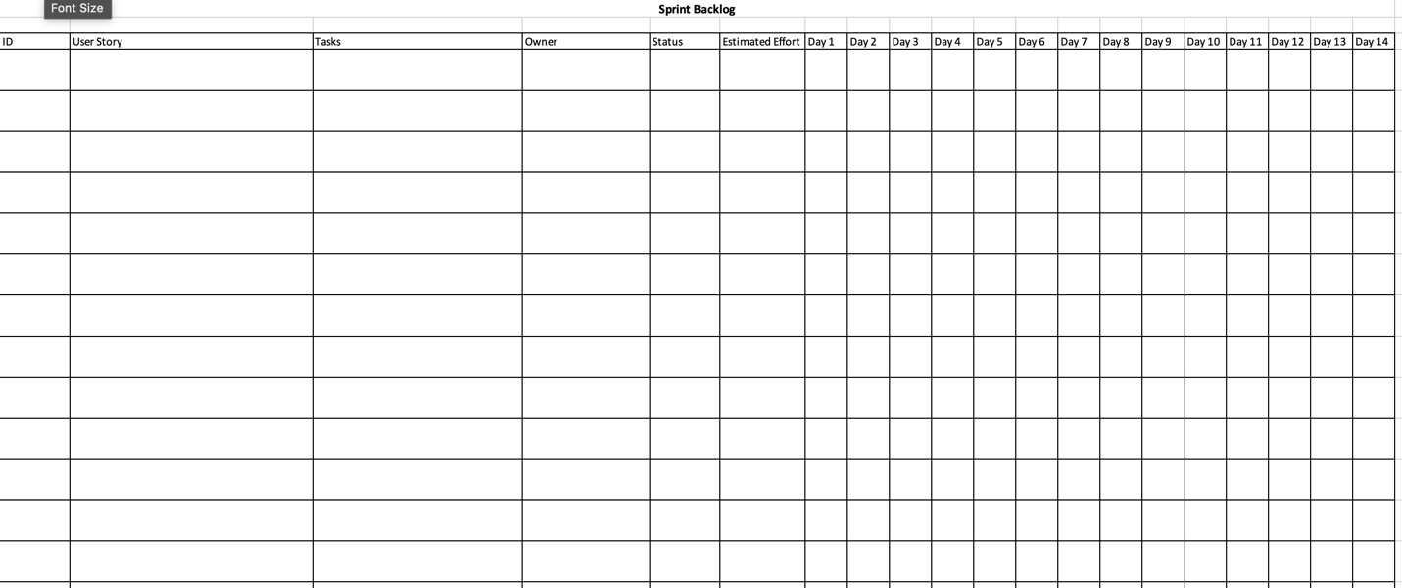

**Samples Objectives**

**Sprint Objectives for City Building Cardboard Scrum Game**

* Design and build the basic infrastructure of the city, including roads, utilities, and zoning areas.
* Develop and construct key public facilities such as schools, hospitals, and parks to improve the quality of life for citizens.
* Implement housing affordability measures to ensure that a range of income levels can access suitable housing within the city.
* ~~Integrate environmental sustainability practices into the city's development plan, such as green spaces and renewable energy sources.~~
* Enhance the quality of life for residents by prioritizing amenities such as retail spaces, restaurants, and cultural venues within walking distance of residential areas.
* Implement a transportation system that efficiently connects different parts of the city and minimizes traffic congestion.
* Integrate iconic buildings into the city's overall urban planning strategy, ensuring that they contribute to the functional and aesthetic cohesion of the built environment.
* ~~Design and construct government buildings that serve as functional and symbolic centers of civic governance, including city halls, administrative offices, and public meeting spaces.~~

**Product Backlog**

Epic

Epic: Build Buildings

* Story: As a player, I want to be able to construct different types of buildings, such as residential, commercial, industrial, and public, so that I can create a diverse and functional cityscape.

Epic: Road Network

* Story: As a player, I want to be able to build a comprehensive road network with main roads, secondary roads, intersections, traffic signs, and pedestrian walkways, so that I can establish efficient transportation routes and ensure safe movement within the city.

Epic: Parks and Open Spaces

* Story: As a player, I want to be able to create parks with green spaces, trees, playgrounds, recreational areas, benches, and picnic areas, so that I can provide the community with enjoyable and relaxing outdoor spaces.

Epic: Landmarks and Iconic Structures

* Story: As a player, I want to be able to construct famous landmarks, city hall, and unique eye-catching structures, so that I can add visual interest, cultural significance, and identity to the city.

Epic: Transportation System

* Story: As a player, I want to be able to incorporate a transportation system, including a bus network with bus stops, train or subway stations, and parking lots or garages, so that I can facilitate convenient and accessible transportation options for residents and visitors.

Epic: Mini figures

* Story: As a player, I want to be able to populate the city with a variety of mini figures and their corresponding vehicles, so that I can bring life, diversity, and activity to the city environment.

**Product Backlog**

PBI

• Epic: Build Buildings

* PBI 1 - Story: As a player, I want to construct residential buildings, so that I can provide housing for the city's residents.

Acceptance Criteria:

* The residential buildings should have varying sizes and designs to create visual diversity.
* Once built, the residential buildings should be visually distinct and recognizable within the city.
* The residential buildings should be sized proportionately to the capacity to accommodate a specific number of mini figures.
* PBI 2 - Story: As a player, I want to construct commercial buildings, so that I can create spaces for businesses and shops in the city.

Acceptance Criteria:

1. The commercial buildings should have distinct appearances, representing various types of businesses and shops.
2. The commercial buildings should have features like storefronts, signage, and windows to indicate commercial activity.
3. The commercial buildings should support different types of businesses such as retail stores, restaurants, or offices.
4. The commercial buildings should be sized proportionately to the capacity to accommodate a specific number of mini figures.

* PBI 3 - Story: As a player, I want to construct industrial buildings, so that I can support the city's economic activities and provide employment opportunities.

Acceptance Criteria:

* The industrial buildings should represent various sectors, such as factories, warehouses, or production facilities.
* The industrial buildings should have visible features like smokestacks, loading areas, or storage facilities.
* The player should have the ability to assign different types of industries to the industrial buildings, such as manufacturing, logistics, or agriculture.
* The industrial buildings should be sized proportionately to the capacity to accommodate a specific number of mini figures.
* PBI 4 - Story: As a player, I want to construct public buildings, such as schools, hospitals, and government offices, to cater to the needs of the community.

Acceptance Criteria:

* The public buildings should represent essential community services, such as schools, hospitals, libraries, or government offices.
* Each type of public building should have distinct architectural features and design elements that reflect its purpose.
* The public buildings should be sized proportionately to the capacity to accommodate a specific number of mini figures.

• Epic: Road Network

* PBI 5 - Story: As a player, I want to build main roads, so that I can establish the primary transportation routes within the city.

Acceptance Criteria:

* The main roads should be visually distinct from other types of roads within the city.
* The main roads should connect different areas of the city, providing a primary transportation network.
* The main roads should allow for smooth and uninterrupted traffic flow.
* PBI 6 - Story: As a player, I want to build secondary roads, so that I can provide connectivity to different areas of the city.

Acceptance Criteria:

* The secondary roads should have a distinct appearance from main roads.
* The secondary roads should branch off from the main roads and provide connectivity to various neighborhoods and locations within the city.
* The secondary roads should allow for efficient and convenient travel within the city.
* PBI 7 - Story: As a player, I want to build intersections and traffic signs, so that I can ensure safe and efficient traffic flow.

Acceptance Criteria:

* The intersections should allow for smooth and safe merging of traffic from different directions.
* The player should be able to add traffic signs, such as stop signs, yield signs, and speed limit signs, at appropriate locations within the city.
* The traffic signs should provide clear and visible guidance for drivers.
* The intersections and traffic signs should adhere to established road safety standards.
* PBI 8 - Story: As a player, I want to add pedestrian walkways, so that I can accommodate pedestrian movement and encourage walkability.

Acceptance Criteria:

* The pedestrian walkways should be distinguishable from road models.
* The pedestrian walkways should connect different areas of the city, allowing pedestrians to move safely and conveniently.
* The player should be able to add amenities like benches, streetlights, or crosswalks along the pedestrian walkways.
* The pedestrian walkways should provide a separate and safe space for pedestrians away from vehicle traffic.

• Epic: Parks and Open Spaces

* PBI 9 - Story: As a player, I want to create parks with green spaces and trees, so that I can provide recreational areas and promote a healthy environment.

Acceptance Criteria:

* The placement of parks should be within suitable locations in the parks and open spaces.
* The parks should have ample green spaces and areas for grass or vegetation.
* The parks should include trees of various types and sizes to create a visually appealing and natural environment.
* The layout and design of the park should be attractive and practical with features such as paths and seating areas.
* The parks should be visually distinguishable from other types of spaces within the city.
* PBI 10 - Story: As a player, I want to design playgrounds and recreational areas, so that I can cater to the leisure needs of the community, especially children.

Acceptance Criteria:

* The placement of playgrounds should be within suitable locations in the parks and open spaces.
* The playgrounds should include a variety of play equipment, such as swings, slides, climbing structures, and sandbox areas.
* The playgrounds should be designed with safety guidelines in mind, ensuring child-friendly and age-appropriate equipment.
* The layout and design of the playground should be appropriate with proper arrangement of equipment and seating areas.
* The playgrounds should be visually distinct and recognizable within the city.
* PBI 11 - Story: As a player, I want to add benches and picnic areas, so that people can rest and engage in outdoor activities.

Acceptance Criteria:

* The placement of benches and picnic areas should be within suitable locations in the parks and open spaces.
* The benches should provide comfortable seating for individuals or small groups.
* The picnic areas should provide tables and seating, allowing people to gather and have meals in outdoor settings.
* The bench and picnic areas should be visually distinguishable within the park or open space.

• Epic: Landmarks and Iconic Structures

* PBI 12 - Story: As a player, I want to construct famous landmarks so that I can create points of interest and attractions in the city.

Acceptance Criteria:

* The landmarks should be recognizable and accurately represent the city.
* The landmarks should have distinct architectural features and design elements that make them visually appealing and visually distinct within the city.
* PBI 13 - Story: As a player, I want to build a city hall and other government buildings, so that I can add identity and administrative functionality to the city.

Acceptance Criteria:

1. The government buildings should have a distinctive architectural style and design that represents the administrative and bureaucratic nature of such structures.
2. The government buildings should be placed relatively center to the city area.
3. The government buildings should have good accessibility so that it can accommodate large number of visitors.
4. The player should receive visual and audio feedback confirming the successful construction of a government building.

• Epic: Transportation System

* PBI 14 - Story: As a player, I want to build public transportation systems, such as bus stops and train stations, to facilitate efficient movement within the city.

Acceptance Criteria:

1. The bus stops and train stations should be strategically located throughout the city to serve different areas and neighborhoods.
2. The transportation systems should have a visually distinctive design, making them easily recognizable.
3. The transportation systems should have features such as shelters, seating, and signage.
4. The transportation systems should provide convenient access and waiting areas for passengers.

* PBI 15 - Story: As a player, I want to construct roads of different sizes, so that I can establish a comprehensive transportation network in the city.

Acceptance Criteria:

* The roads should connect different areas of the city, providing a comprehensive transportation network.
* The roads should allow for smooth and uninterrupted traffic flow.
* The roads should be visually distinguishable from other types of spaces within the city.
* PBI 16 - Story: As a player, I want to design parking lots or garages, so that I can cater to the parking needs of people traveling by private vehicles.

Acceptance Criteria:

* The parking lots or garages should have a visually distinguishable design that reflects their purpose.
* The city should have appropriate size and layout of the parking lots or garages to accommodate different capacities.
* The parking lots or garages should have clearly marked parking spaces and aisles for easy navigation.
* The player should be able to incorporate features like entrances, exits, and ramps for seamless vehicle movement.
* The parking lots or garages should be strategically located within the city to cater to the parking needs in different areas or near popular destinations.

• Epic: Mini figures

* PBI 17 - Story: As a player, I want to populate the city with various types of mini figures, so that I can bring life and variety to the city's streets and spaces.

Acceptance Criteria:

* The mini figures should have a variety of designs, representing different occupations, age groups, and demographics.
* The mini figures should be visually appealing and detailed, with distinct characteristics that make them easily recognizable.
* The mini figures should be scaled appropriately to the environment, ensuring they appear in proportion to the buildings and scenery.
* The mini figures should simulate daily activities, such as walking, talking, or interacting with objects.
* PBI 18 - Story: As a player, I want to add vehicles for the mini figures, so that I can create a realistic and animated city environment.

Acceptance Criteria:

* The vehicles should represent various types, such as cars, trucks, buses, bicycles, and motorcycles.
* The vehicles should have visually appealing and detailed designs, with distinct characteristics that make them easily recognizable.
* The vehicles should come in various color, style, and features.
* The vehicles should adhere to road rules and traffic regulations, such as stopping at traffic lights and yielding to pedestrians.